|  |  |  |  |  |  |  |  |
| --- | --- | --- | --- | --- | --- | --- | --- |
| **Date:** | **29-06-2020** | | | | **Name:** | **Vidya K C** | |
| **Sem & Sec** | **6th - B** | | | | **USN:** | **4AL17CS107** | |
| **Online Test Summary** | | | | | | | |
| **Subject** | **DBMS**  **Cyber Security** | | | | | | |
| **Max. Marks** | **-** | | **Score** | | | **-** | |
| **Certification Course Summary** | | | | | | | |
| **Course** | 1. **Pre-Placement Training** | | | | | | |
| **Certificate Provider** | | **-** | | **Duration** | | | **-** |
| **Coding Challenges** | | | | | | | |
| **Problem Statement:Python program** | | | | | | | |
| **Status: Executed** | | | | | | | |
| **Uploaded the report in GitHub** | | | | **yes** | | | |
| **If yes Repository name** | | | | <https://github.com/alvas-education-foundation/DAILY_STATUS_> | | | |
| **Uploaded the report in slack** | | | | **Yes** | | | |

**DBMS:**

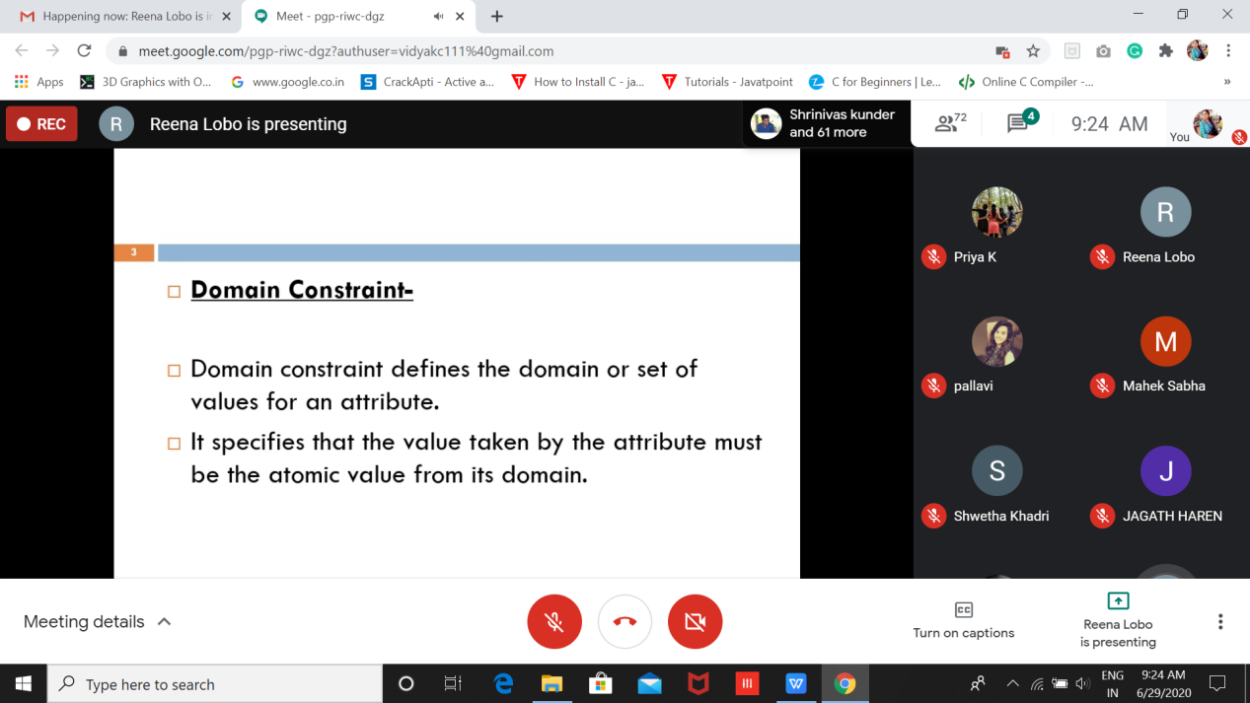

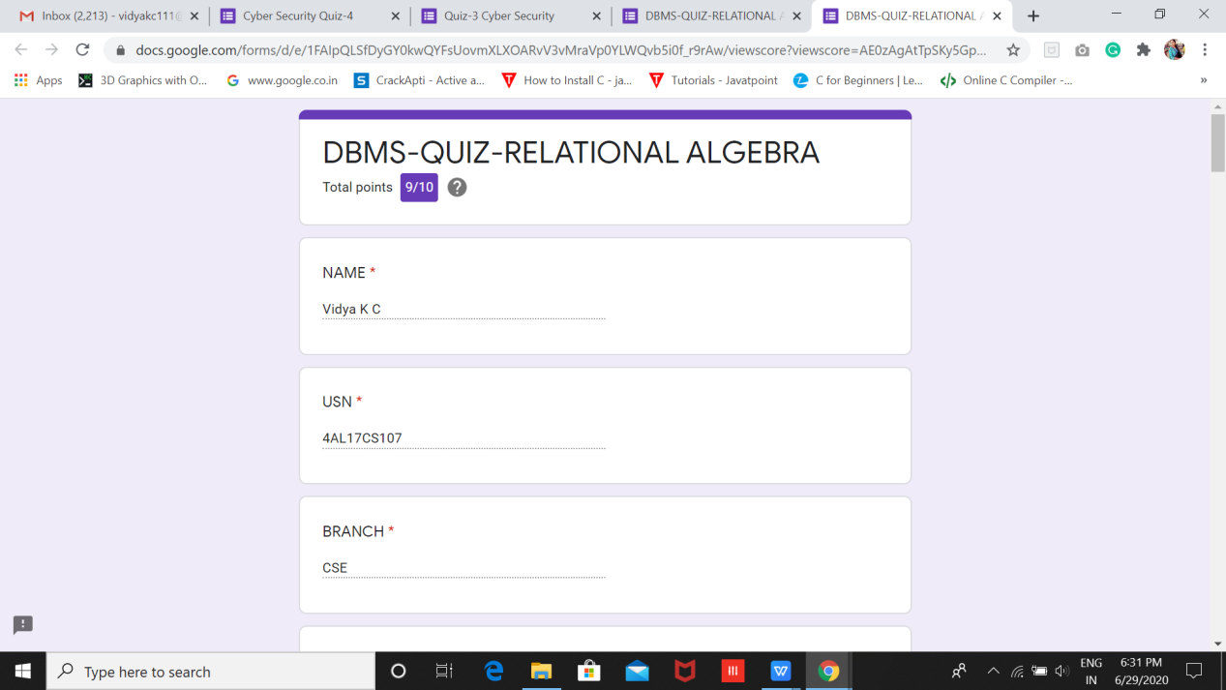

**Cyber Security**

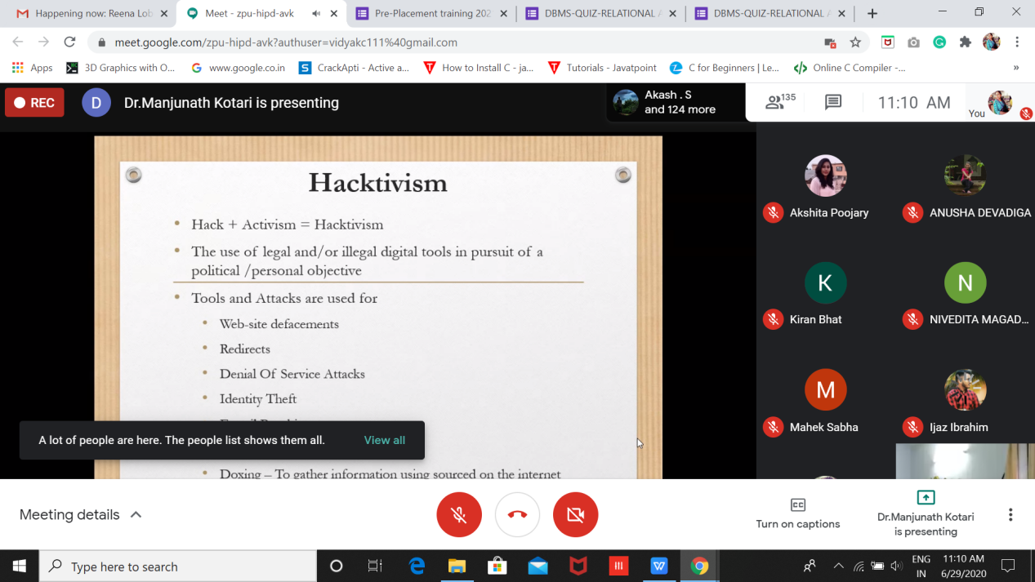

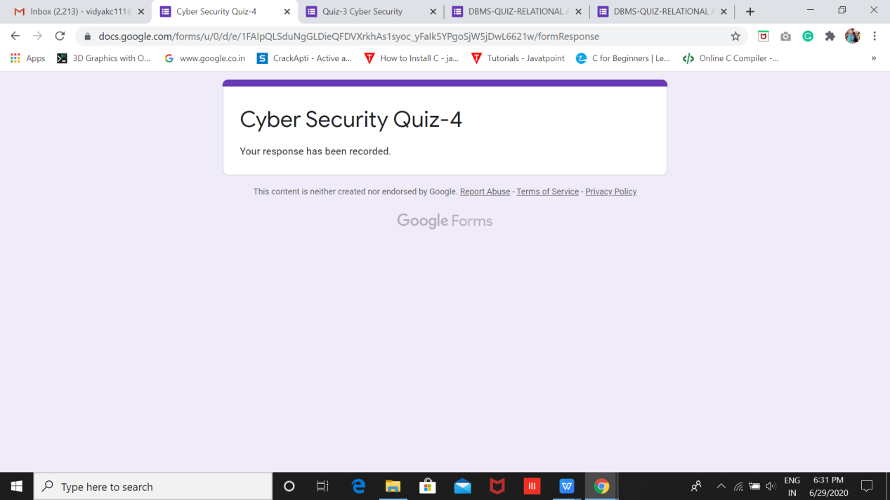

**Coding**

1.Python Program to Count the Number of Occurrences of an Element in the Linked List without using Recursions

